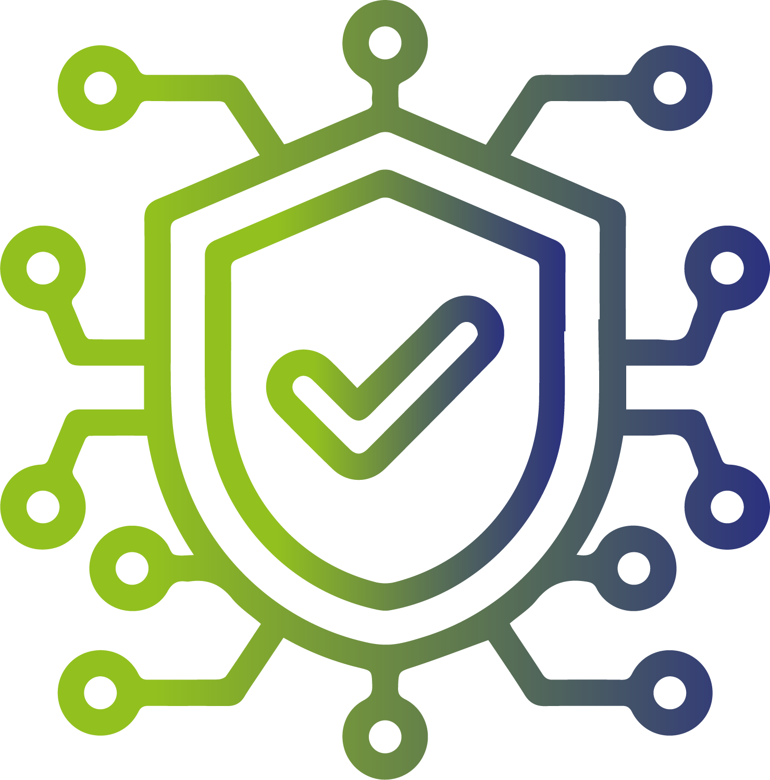

La Sécurité Matériel / Logiciel



Matériel

- 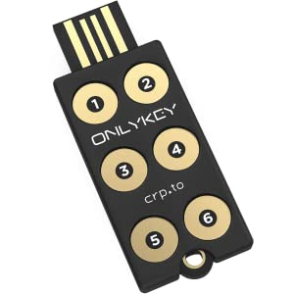 Onlykey | - 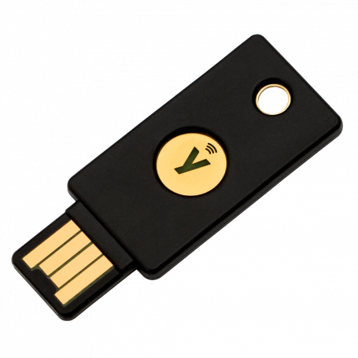 Yubikey



Logiciel

-  AIDE Advanced Intrusion Detection Environment | IDS & FIM Tools
-  CyberSécurité Article sur outils de Kali Linux
- 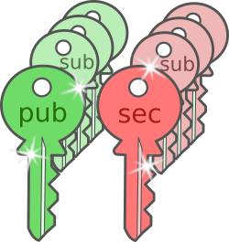 GPG GNU Privacy Guard | Cryptographic Tools
-  Lynis Audit System Tools
-  OpenSCAP Audit System Tools (RGPD / ISO27001 / PCI-DSS )
-  RKHunter RootKit Analysis Tools

